Bitcoin Accumulation Beyond Uniform DCA
A data-driven framework using on-chain and prediction market signals

OMSA Practicum
Team 08: Chenhao Qian, Shuang Gong

Contents
Executive Summary 3
1. Introduction and Business Justification 4
Project contributions 4
2. Data, Literature Context, and Feature Pipeline 5
2.1 Data sources 5
2.2 Literature and conceptual context 5
2.3 Data wrangling and feature engineering 5
3. Exploratory Data Analysis and Signal Development 7
3.1 Signal 1 — on-chain value and active churn 7
3.2 Signal 2 — macro event anchor 8
3.3 Signal 3 — whale smart money 9
3.4 Signal 4 — Polymarket risk index as regime filter 10
3.5 Additional EDA observations 11
4. Model Design and Backtesting Framework 12
4.1 Model architecture 12
4.2 Budget preservation and evaluation design 12
4.3 Why a rule-based model 12
5. Results, Interpretation, and Benchmark Comparison 13
5.1 Headline Results 13
5.2 Improvement Contribution 13
5.3 Why the strategy beats DCA even without perfect timing 14
6. Troubleshooting, Unsuccessful Attempts, and Regime Misses 14
6.1 The important miss: September 2022 to January 2023 14
6.2 Iterative fixes we considered 15
6.3 What the miss taught us 15
7. Limitations, Future Work, and Lessons Learned 16
7.1 Limitations 16
7.2 Future work 16
7.3 Lessons learned 16
Conclusion 17
Appendix A. Selected Figures 18

Executive Summary
Dollar-cost averaging (DCA) remains one of the most common ways to accumulate Bitcoin because it is simple, disciplined, and easy to stick with over time. At the same time, it rests on a strong assumption: that every day is equally worth buying. In this project, we asked whether that assumption could be improved upon without turning the problem into short-term price prediction.
Rather than trying to forecast where Bitcoin would go next, we focused on a more practical question. If the goal is long-term accumulation, are there market conditions that tend to be better entry environments than others? To explore that question, we combined Bitcoin on-chain data with prediction market data from Polymarket and tested whether a rule-based, interpretable framework could allocate capital more effectively than uniform DCA.
The strongest result from our analysis is that valuation still matters most. Lower MVRV regimes were consistently associated with better accumulation outcomes. At the same time, the best entry windows were not usually the most extreme panic periods. They appeared more often in what we describe as an active churn regime: Bitcoin looked relatively undervalued, exchange net flows showed moderate outflows, and on-chain participation remained healthy. This combination turned out to be more useful than looking at valuation in isolation.
Polymarket data also added value, but in a more indirect way. Event activity worked better as a risk filter than as a return predictor. When macro event flow was active, forward drawdown risk tended to be lower; when event flow was quiet, downside risk was often higher. Whale directional flow and a probability-volatility risk index offered some additional context, although both were weaker than the core on-chain signals.
At the current stage of the project, the tuned final model outperforms uniform DCA in 68.56% of 2,557 rolling windows, with mean relative improvement of 21.62% and median relative improvement of 20.48%. It also outperforms a simpler 200-day moving-average baseline and an earlier Polymarket-enhanced example model. The main miss remains the September 2022 to January 2023 transition, where the framework stayed too defensive during the early recovery phase. That miss is analytically important: it reveals that accumulation models can struggle not in obvious overvaluation or capitulation regimes, but in turning points when valuation is cheap yet trend filters remain bearish.
Overall, the project shows that better Bitcoin accumulation comes less from perfect prediction and more from smarter filtering. The most effective improvements did not come from one exotic signal; they came from combining a strong valuation anchor with regime-aware overlays and iterative troubleshooting.

1. Introduction and Business Justification
DCA is popular for a good reason. Most investors do not have a reliable way to call tops and bottoms, and trying to time every move usually leads to inconsistent decisions. A fixed buy schedule solves that problem by replacing judgment with discipline, but it ignores the possibility that some environments are systematically better entry regimes than others.
In the world of bitcoin and crypto investment, this creates a useful business question: can a disciplined investor preserve the simplicity of DCA while improving capital timing through transparent signals? A positive answer matters because even modest improvements in bitcoin accumulated per dollar compound meaningfully over multi-year horizons. An accumulation strategy that buys slightly more aggressively when the asset is structurally cheap and slightly less aggressively when conditions are unfavorable can potentially improve long-run holdings without requiring leverage, discretionary timing, or black-box prediction.
This framing also fits a realistic product perspective. The output of the model is not a trading signal such as 'buy' or 'sell' for a fully invested portfolio. Instead, it tells us periods that were more favorable for long-term accumulation and scale buying intensity up or down accordingly.
Our project answers below three research questions:
- Do on-chain valuation and participation indicators identify systematically better Bitcoin accumulation windows?
- Do prediction-market features from Polymarket add useful information about risk, sentiment, or speculative conviction?
- Can a rule-based dynamic allocation framework outperform uniform DCA on a rolling out-of-sample style backtest while remaining interpretable?

Project contributions
- A signal-development process grounded in exploratory analysis rather than arbitrary feature inclusion.
- A hybrid framework that blends long-history on-chain data with shorter-history Polymarket context features.
- A clear diagnosis of where the strategy works, where it fails, and why the difficult Sep 2022-Jan 2023 regime transition remains a key weakness.

2. Data, Literature Context, and Feature Pipeline

2.1 Data sources
The project uses two main data sources. The first is the Coin Metrics dataset. This is the on-chain data and the historical backbone of the project. It contains daily Bitcoin observations from 2018-01-01 through 2025-12-31. This dataset includes price, market capitalization, MVRV, exchange inflows and outflows, active address count, transaction activity, and other network-level indicators. From those raw variables, we also built derived features such as 30-day forward returns, forward drawdown, rolling volatility, distance from the 200-day moving average, and drawdown from the all-time high.
Polymarket data provide the speculative and macro-overlay. It covers the polymarket from 2023 through 2026. The project uses finance and politics exports covering markets, tokens, trades, odds history, and event-level statistics. From these data, we created daily features such as active event count, total active volume, a whale directional flow measure based on larger trades, and a Polymarket risk index based on rolling probability volatility.

2.2 Literature and conceptual context
The project sits at the intersection of three literatures. The first is the classic DCA-versus-timing debate, which generally concludes that disciplined contribution schedules are behaviorally robust but not informationally efficient. The second is the on-chain valuation literature for Bitcoin, where indicators such as MVRV, exchange flows, and activity measures are often interpreted as proxies for valuation, holder behavior, and network health. The third is prediction-market research, which treats market prices as aggregators of dispersed information and views order flow or probability volatility as useful signals about uncertainty and conviction.
Our implementation deliberately avoids pretending that one signal can fully solve the accumulation problem. Instead, it uses MVRV as the valuation anchor, participation and netflow as state descriptors, and Polymarket features as regime filters. This design choice follows the empirical pattern in the EDA: on-chain data explain the bulk of the signal, while prediction-market features refine the context in which the on-chain signal should be trusted more or less.

2.3 Data wrangling and feature engineering
- Restricted the Coin Metrics sample to 2018-01-01 through 2025-12-31 and verified no missing dates in the daily index.
- Computed daily returns, log returns, 30-day realized volatility, drawdown, price relative to the 200-day moving average, 30-day forward return, and forward maximum drawdown.
- Converted exchange inflows and outflows into netflow-oriented features and standardized several features using rolling z-scores or percentiles to make heterogeneous signals comparable.
- Built Polymarket daily features from market metadata, odds history, trades, and event statistics, then aligned them to the Bitcoin daily calendar.
- Lagged all model inputs by one day before scoring to avoid look-ahead bias.
- Used quintile binning extensively in the EDA to identify monotonic or non-monotonic regime structure before turning variables into model components.
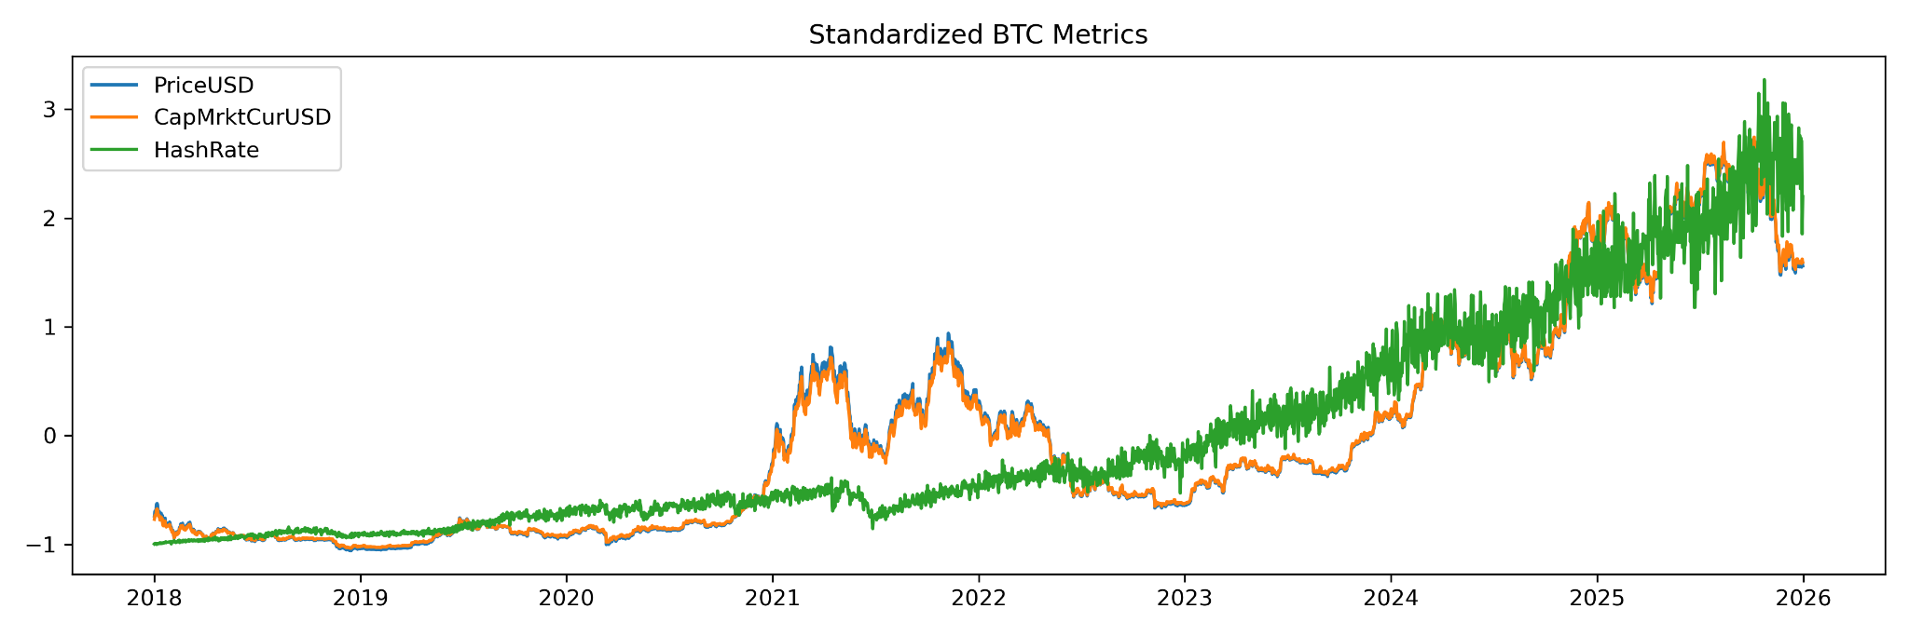
Figure 1. Standardized Bitcoin price, market capitalization, and hash rate show cyclical price behavior on top of a longer-run structural network-growth trend.

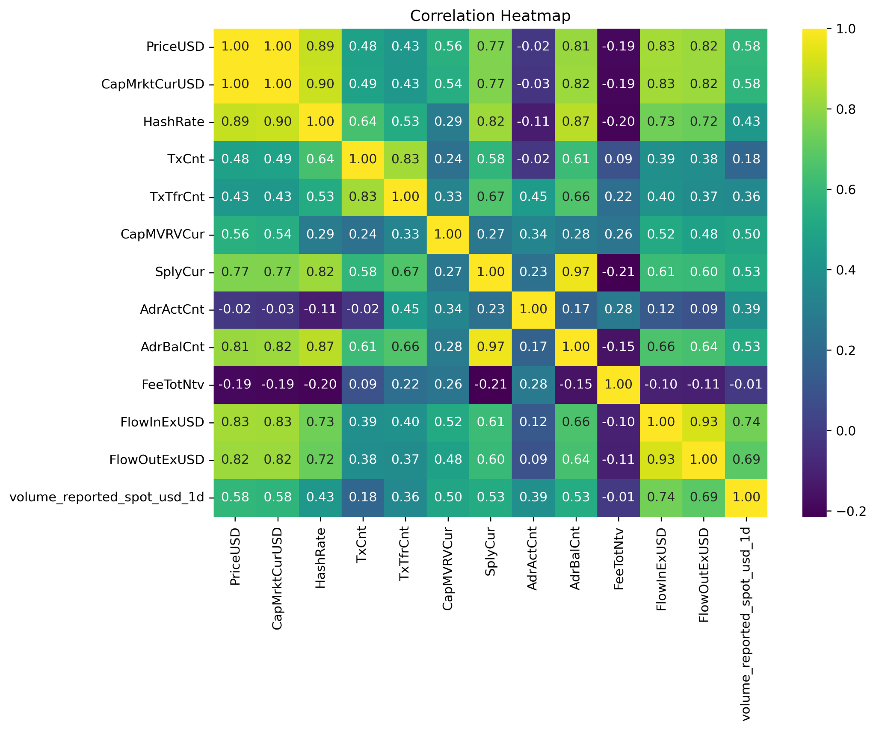
Figure 2. Correlation structure supports using netflow instead of raw inflow/outflow individually and suggests active addresses carry information that is not mechanically redundant with price.

3. Exploratory Data Analysis and Signal Development
To make our findings more coherent, we organized this section around four signals that emerged most clearly from the exploratory analysis. Rather than listing every pattern we observed, we focused on the signals that helped answer our main question: whether Bitcoin accumulation can be improved by identifying more favorable market environments instead of treating every day as equally attractive. These four signals are on-chain value and active churn, macro event anchoring, whale smart money, and the risk index regime filter.

3.1 Signal 1 — on-chain value and active churn
The strongest signal in our analysis came from on-chain valuation, especially when combined with participation. Across the full sample, lower MVRV regimes were generally associated with better forward accumulation conditions, confirming that valuation remains the most reliable starting point for long-term Bitcoin buying. This was the clearest pattern we found, and it became the foundation for the rest of the framework.
At the same time, our results suggested that valuation alone was not enough. The best accumulation windows did not usually appear during the most extreme panic or disorder. Instead, they tended to appear when Bitcoin looked undervalued, exchange flows showed moderate outflows, and network participation remained relatively healthy. We refer to this combination as active churn. What makes this signal useful is that it captures a more constructive kind of weakness: price is attractive, but the network still looks active rather than broken.
This turned out to be one of the most important insights in the project. It suggests that the best buying environments are not necessarily the most chaotic ones, but those in which undervaluation is still supported by continued participation. Figure 1 shows this pattern, where the strongest forward outcomes appeared when value and participation conditions aligned.
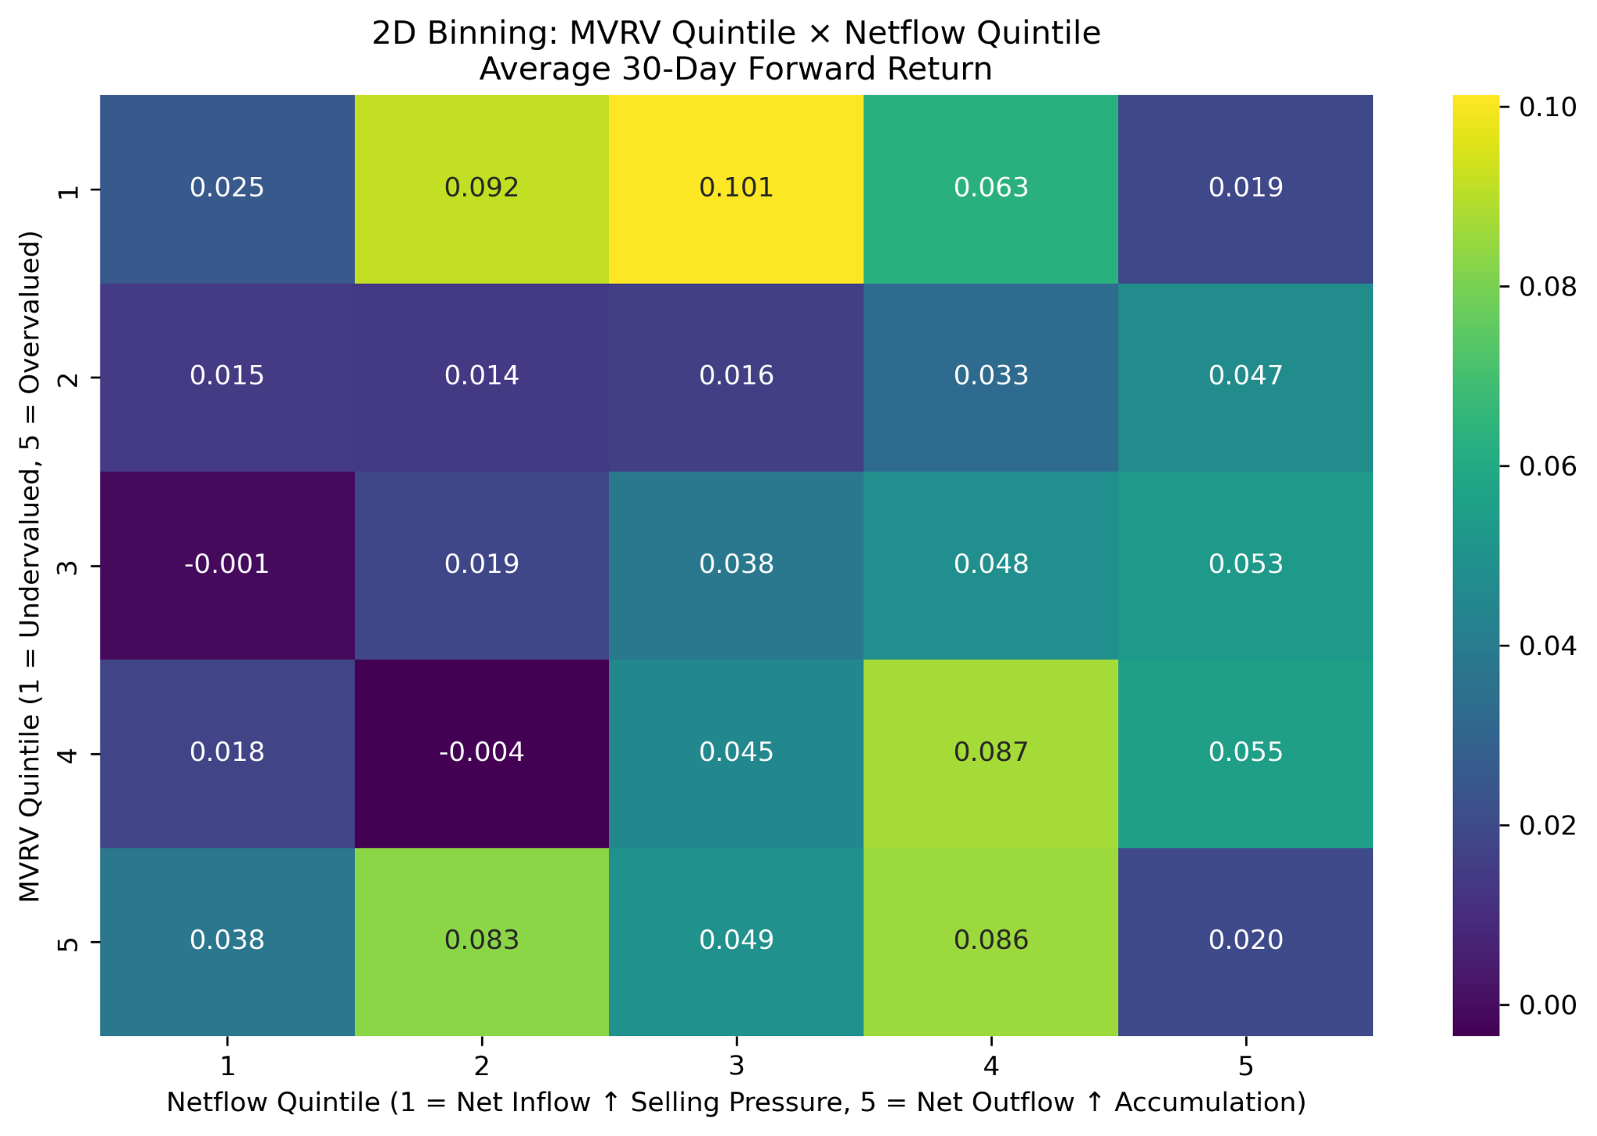
Figure 3. MVRV quintile x netflow quintile. The strongest 30-day forward returns occur when valuation is attractive and netflow is constructive, rather than in indiscriminate panic alone.

3.2 Signal 2 — macro event anchor
The second signal came from prediction-market event activity. When we first incorporated Polymarket data, one of our main questions was whether event activity might help predict Bitcoin returns more directly. What we found was more subtle. Event activity did not consistently behave like a strong return predictor, but it did appear useful as a macro anchor for risk conditions. Periods with more active prediction-market events tended to coincide with lower downside risk in the following period, while quieter periods often looked more vulnerable. We interpret this as a difference between markets with an active information flow and markets with relatively little anchoring information. When event activity is high, market participants are responding to visible macro narratives and repricing expectations in a more structured environment. When it is low, the market may be more exposed to unanchored sentiment and adverse moves.
For that reason, we treated macro event activity less as an alpha signal and more as a contextual guide. It helped us distinguish between environments in which undervaluation could be acted on more confidently and those in which caution was more appropriate. Figure 4 illustrates this relationship by showing that event activity was more informative for downside-risk filtering than for predicting return magnitude directly.
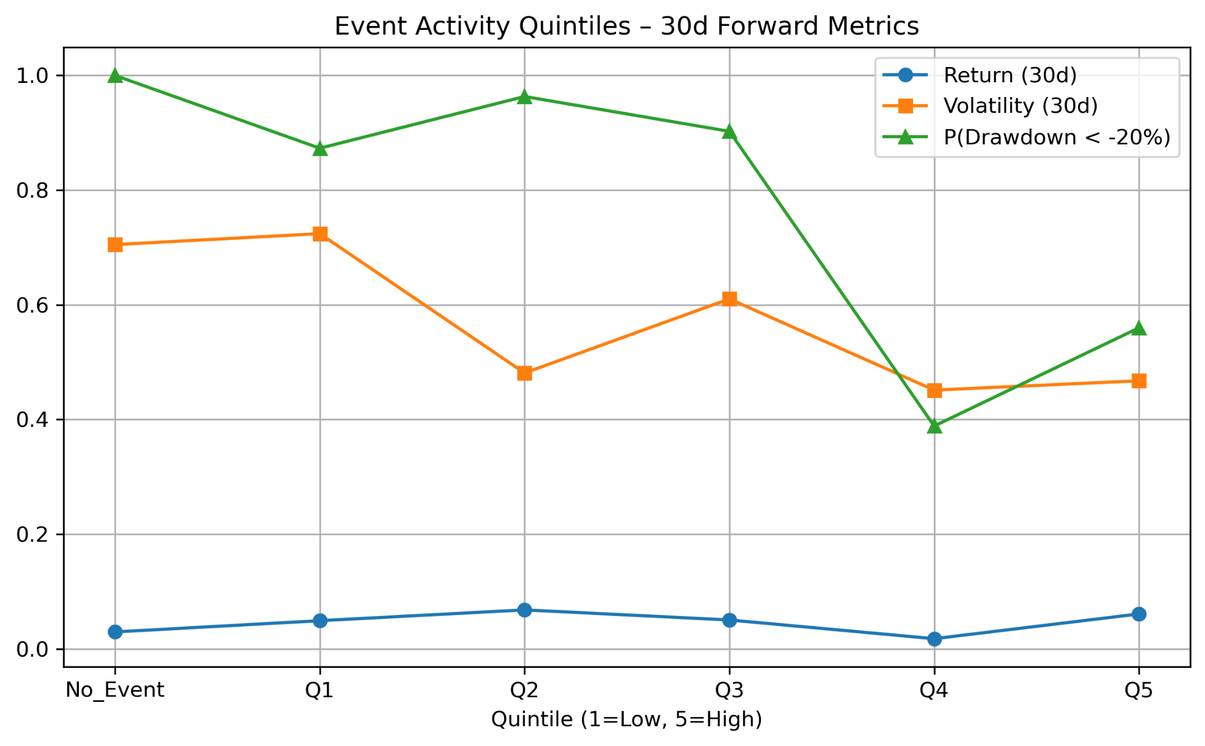
Figure 4. Event-activity quintiles are more informative for drawdown filtering than for forecasting return magnitude.
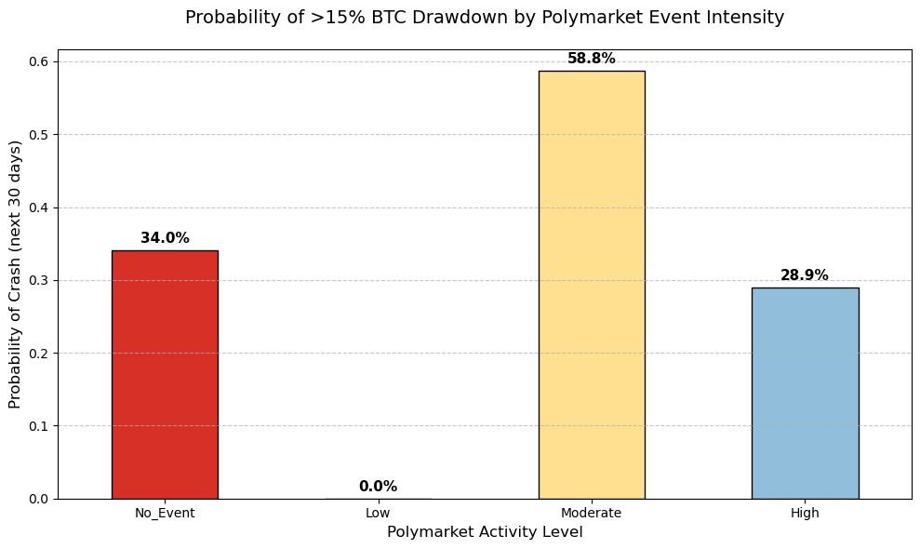
Figure 5. The probability of a >15% Bitcoin drawdown varies materially across event-intensity regimes, reinforcing the interpretation of event activity as a risk filter.

3.3 Signal 3 - smart money
The trades dataset is highly concentrated, with a small number of large participants driving a disproportionate share of notional flow. This motivates the whale signal. In our analysis, more bullish large-bet net flow was generally associated with better forward accumulation conditions. We define smart-money trades using a notional threshold and then aggregate directional flow into a daily net signal.
Empirically, whale flow shows a modest lead-lag relationship with future Bitcoin returns, and the most bullish quintiles are associated with better average 30-day forward returns than the most bearish quintiles. This result was interesting because it pointed to the possibility that larger participants may at times reveal directional conviction earlier than broader market behavior does, especially when combined with the stronger on-chain signals. At the same time, this was not one of the most mature parts of the project. The caveat is sample length: the trade export available in this project begins only in April 2025, so the signal is promising but not yet fully tested over entire cycle.
For that reason, we did not treat whale flow as a primary anchor on its own. Instead, we viewed it as a lighter overlay that could strengthen or weaken conviction around the main regime signals. In other words, it was useful, but not strong enough to carry the framework by itself.
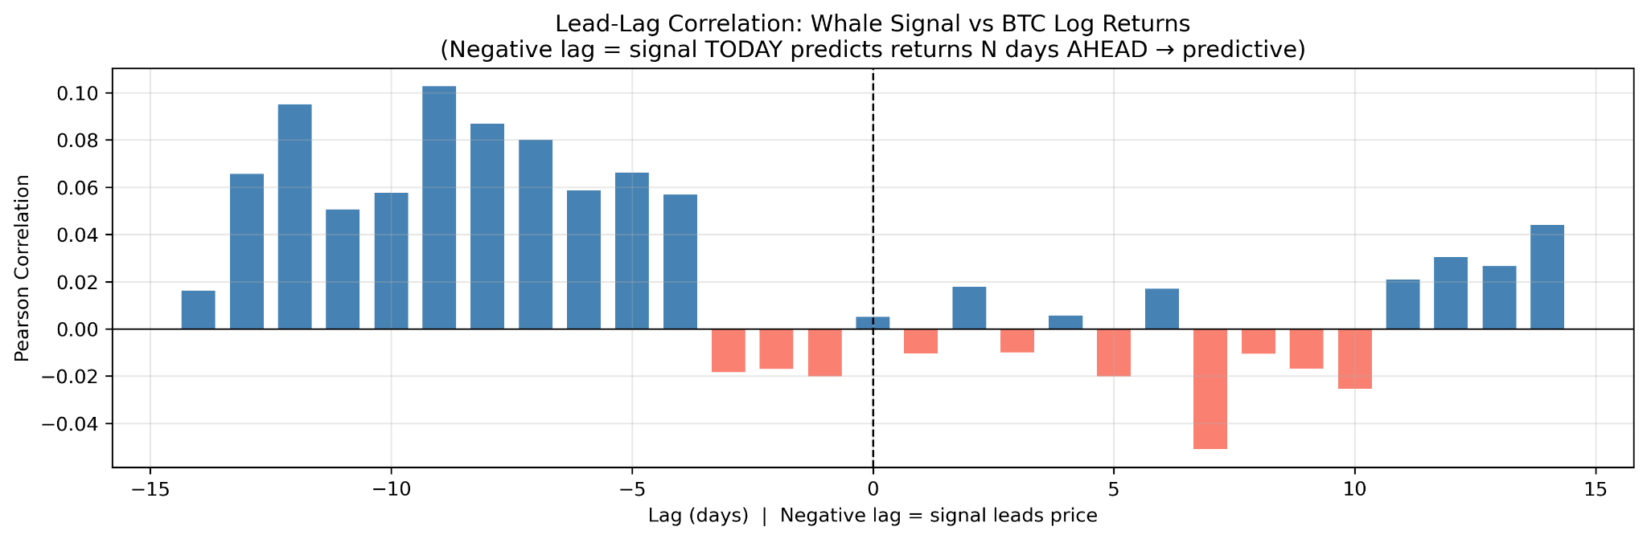
Figure 6. Whale directional flow has a mild positive predictive tilt at short forward lags, consistent with a weak but usable smart-money overlay.
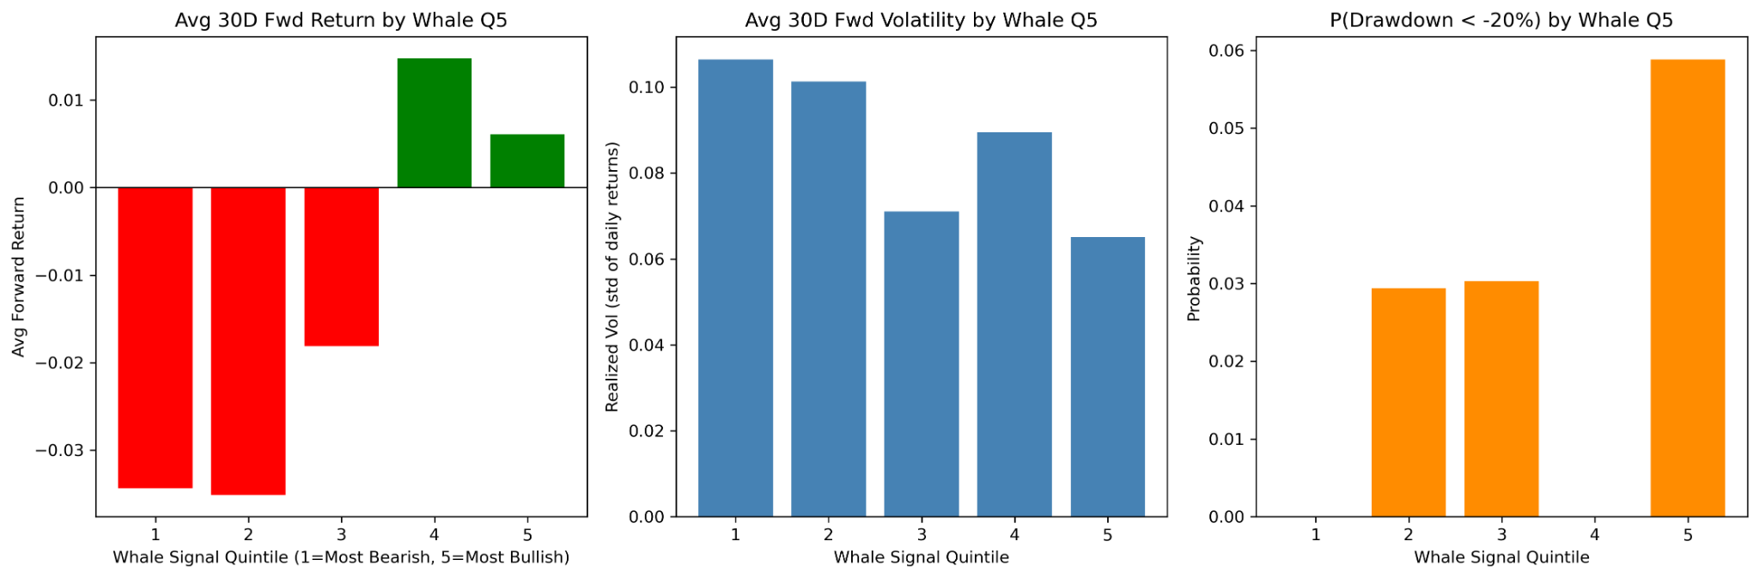
Figure 7. More bullish whale-flow quintiles are generally associated with better forward return profiles than bearish quintiles, although the sample is short.

3.4 Signal 4 — Polymarket risk index as regime filter
The risk index is constructed from cross-market probability volatility in the Polymarket odds history. Conceptually, high values indicate rapid repricing of beliefs across many markets, while low values indicate more stable expectations. This makes the index a natural candidate for regime description rather than directional alpha.
In the EDA, the risk index co-moves with high-price, high-attention phases, especially around late-2024 macro events (US election). That is useful context, but it is not enough to justify using the index as a raw bullish signal. Instead, it enters the model as a regime modifier that scales conviction around stronger underlying signals.
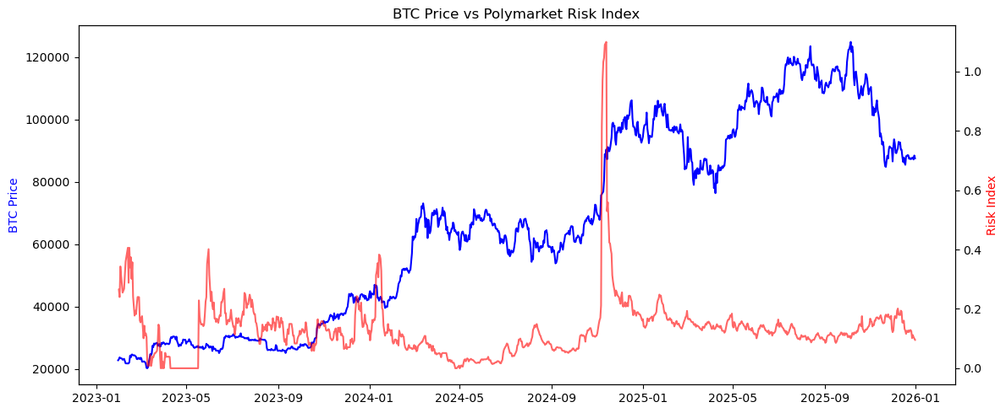
Figure 8. Bitcoin price and the Polymarket risk index show that macro-uncertainty spikes cluster around major event periods and should be interpreted as regime context, not as a simple long signal.
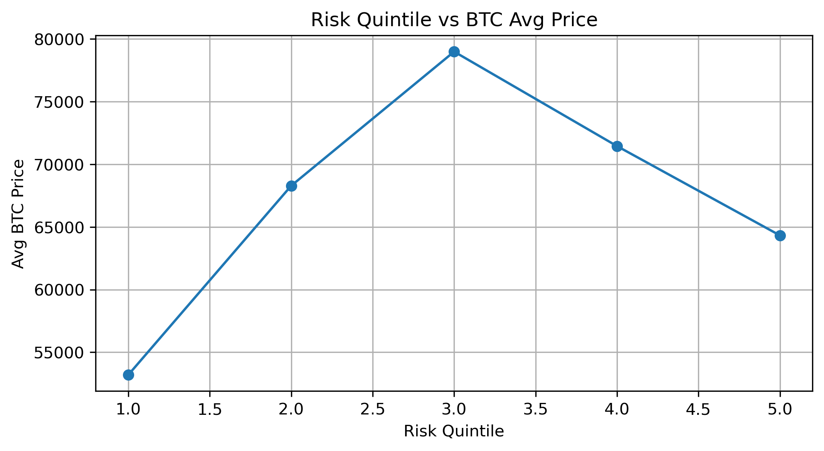
Figure 9. The prediction-market risk index functioned mainly as a regime filter, helping distinguish between different macro uncertainty environments.

3.5 Additional EDA observations
- The Coin Metrics dataset is structurally clean: 2,922 daily observations with strong completeness for key variables.
- Market and event activity in Polymarket are highly concentrated in macro-political clusters such as U.S. elections, inauguration, and Fed decisions.
- Threshold sensitivity checks show that a relatively high notional cutoff is appropriate for isolating whale behavior from retail noise.
- Cross-correlation tests for event-activity volume are weak, reinforcing the interpretation that event flow helps more with regime classification than direct price prediction.

4. Model Design and Backtesting Framework

4.1 Model architecture
The final strategy is deliberately interpretable. Each day receives an allocation multiplier relative to uniform DCA. The model first forms an additive core score and then applies lighter multiplicative gates. This preserves the logic of a weighted accumulation engine while allowing context-sensitive adjustments.
Signal | Weight | Interpretation
MVRV value signal | 45% | Lower rolling z-score implies undervaluation and increases allocation.
Price vs. 200-day MA | 12% | Price below the long-run trend supports larger buys, but only as a secondary signal.
Active churn composite | 21% | Moderate outflow plus active addresses indicate constructive weakness -> buy more
Whale directional flow | 10% | More bullish large-trade net flow modestly increases conviction.

The additive score is refined using several multiplicative gates:
- MVRV acceleration modifier: amplifies or dampens the value signal depending on whether cheapness is strengthening or fading.
- Signal-confidence boost: modestly increases exposure when MVRV and trend context agree.
- Macro-event modifier: dampens exposure near event-resolution windows and during informational vacuums where drawdown risk is empirically higher
- Risk-regime filter: uses the Polymarket risk index to trim or expand conviction in different macro uncertainty regimes.

4.2 Budget preservation and evaluation design
The raw daily multipliers are normalized within each one-year window so that total capital deployed sums exactly to the same budget as uniform DCA. This is a crucial design feature: any improvement in sats-per-dollar (SPD) comes from better timing, not from deploying more money.
The backtest uses rolling one-year windows starting on 2018-01-01. For each window, the strategy is compared with uniform DCA. A win is recorded when the model achieves a higher SPD than uniform DCA. In addition to win rate, we track mean and median relative improvement, percentile-based timing metrics, and an overall composite score which is a weighted average of win rate and exponential decay percentile.

4.3 Why a rule-based model
A machine learning based model might fit the available data more tightly, but it would obscure why capital is being shifted across time. Because the project is about accumulation rather than speculative trading, interpretability is especially valuable. The framework should be understandable enough for an investor or product user to answer a simple question: why is the model asking me to buy more today than yesterday?

5. Results, Interpretation, and Benchmark Comparison

5.1 Headline Results
The report evolved in stages. The earlier sample report summarized a strong but not yet fully tuned version of the strategy. After additional troubleshooting and parameter refinement, the current final model improved further. The table below distinguishes the current tuned strategy from the earlier baseline comparators.
Metric | Final tuned model | DCA + 200MA baseline | Example 1 model
Final Model Score | 65.86% | 51.74% | 59.54%
Win Rate | 68.56% | 61.05% | 60.31%
Exponential Decay Percentile | 63.16% | 42.43% | 58.78%
Mean Excess Percentile | +7.95% | +1.04% | +5.70%
Median Excess Percentile | +7.66% | +1.23% | +6.43%
Mean Relative Improvement | +21.62% | +2.61% | +16.82%
Median Relative Improvement | +20.48% | +3.37% | +17.99%
Mean Ratio (Dynamic/Uniform) | 1.22 | 1.03 | 1.17
Across 2,557 rolling windows, the tuned final model wins in 1,753 windows and loses in 804. This is a meaningful improvement over both comparators. The average relative gain of roughly 21.6% means that, on average, the same dollar budget converted into substantially more satoshis than a uniform DCA schedule.

5.2 Improvement Contribution
- MVRV remained the dominant source of signal and consistently identified better long-run entry regimes than neutral or expensive valuation states.
- The active-churn composite added the most useful incremental improvement by distinguishing constructive weakness from indiscriminate panic.
- Event-intensity and risk-regime features improved risk awareness more than raw upside capture.
- Whale flow was directionally helpful in recent periods but should still be treated as a lighter overlay because of sample-length limitations.

5.3 Why the strategy beats DCA even without perfect timing
The model does not need to call precise bottoms. It only needs to deploy relatively more budget on better-than-average days and relatively less on worse-than-average days. That is exactly what SPD measures. The edge arises from repeated small allocation shifts across many windows rather than from a handful of heroic predictions.

6. Troubleshooting, Unsuccessful Attempts, and Regime Misses

6.1 The important miss: September 2022 to January 2023
The most instructive period of underperformance occurs from late 2022 into early 2023, immediately after the FTX collapse and during the early recovery that followed. As shown in Figure X, the dynamic strategy’s SPD percentile falls sharply below the uniform DCA benchmark around the 2022–2023 window, before recovering later. This is not best understood as a case where the model simply “bought the wrong regime.” Instead, it reflects a regime-transition failure. By that stage, valuation signals such as MVRV were already indicating that Bitcoin had become historically cheap after the Terra/Luna and FTX dislocations, so the model correctly recognized deep undervaluation. However, the broader framework was intentionally designed to avoid buying too aggressively in unstable environments, and trend-sensitive components such as the 200-day moving average, together with macro and risk dampeners, were still suppressing allocations because the market continued to look fragile. As a result, the strategy remained too defensive during the first leg of the rebound.
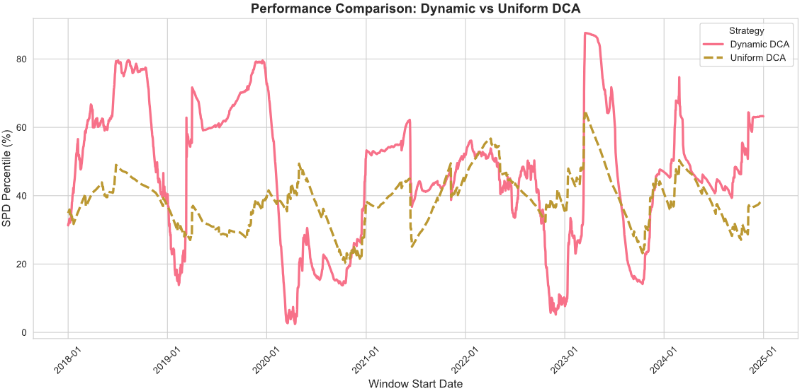
Figure 10. The Dynamic DCA underperformed uniform DCA around late 2022 to early 2033 amid FTXC crash
This period is especially important for an accumulation framework because the earliest phase of recovery is often where front-loaded buying generates the greatest sats-per-dollar advantage. When the model waits for too much confirmation after a crash, it protects against catching a falling knife, but it also risks missing the cheap-to-neutral repricing window that matters most for long-run accumulation efficiency. In this sense, the late-2022 to early-2023 miss reveals a structural tradeoff in the design: the same safeguards that reduce overbuying during breakdowns can delay re-entry when the market begins to heal. The difficulty of this episode was amplified by the fact that participation and exchange-flow measures improved only gradually rather than decisively, making the rebound easy to misclassify as a false dawn. Because Polymarket data do not cover this period, the underperformance should be interpreted primarily as a limitation of the on-chain-plus-trend architecture rather than a failure of the later prediction-market overlays.

6.2 Iterative fixes we considered
The troubleshooting phase focused on whether the model should buy more aggressively when Bitcoin is deeply undervalued even if trend measures remain bearish. One attempted idea was to damp the moving-average influence when MVRV indicated very cheap conditions. The logic was that in capitulation-to-recovery phases, trend can lag too much and suppress needed buying.
Conceptually, this is reasonable. In practice, the trade-off is delicate because reducing the moving-average penalty too much can worsen performance in genuine false rebounds. Since the model normalizes weights within a window, any extra allocation granted during one subperiod must come from another. A local fix to the 2022-2023 miss can therefore degrade broader performance if it overcorrects.
Unsuccessful or only partially successful attempts
- Stronger MA dampening conditional on cheap MVRV: helped the missed rebound narrative but weakened overall robustness because it reduced the model's caution during other weak-trend periods.
- Heavier direct reliance on Polymarket-derived modifiers: added complexity without broad enough historical coverage to justify larger weights.
- Using event activity as a direct upside predictor: the EDA did not support this; event intensity was more reliable as a downside-risk filter.
- Over-amplifying whale-flow influence: recent data show some promise, but the short sample made large weights look statistically fragile.

6.3 What the miss taught us
The key lesson is that accumulation models should be designed to recognize phase changes, not only static cheapness or static trend. The hardest periods are not always obvious crashes; they are transitions where value has already improved but trend confirmation arrives late. This insight directly motivates future work on regime-switching logic and recovery-sensitive modifiers.

7. Limitations, Future Work, and Lessons Learned

7.1 Limitations
- The framework is rule-based and heuristically tuned rather than formally optimized.
- Timeline mismatch: The Polymarket odd history used for risk regime modifier begins in 2023, while trades sample used for whale analysis begins only in 2025, which limits full-cycle validation.
- Some regime modifiers are empirically motivated but still relatively light-touch because a longer history is needed before treating them as primary pillars.

7.2 Future work
A natural next extension is to make the weighting scheme more data-driven through machine learning rather than relying only on heuristic tuning. In the current framework, the signal weights were chosen through exploratory analysis, economic intuition, and repeated back testing, which keeps the model interpretable but does not guarantee that the weights are optimal across different market regimes. A stronger next step would be to train supervised models to learn signal importance directly from historical accumulation outcomes and use that information either to refine the fixed weights or to allow the weights to adapt by regime. Methods such as regularized linear models, gradient-boosted trees, or regime-classification models could be used to estimate how much emphasis should be placed on valuation, moving-average deviation, active churn, whale flow, and macro-event signals under different conditions, while still preserving an interpretable signal set.
Related extensions include building a recovery-aware overlay that more explicitly recognizes the transition from capitulation to early re-acceleration after deep drawdowns, expanding the Polymarket sample and testing richer event-topic segmentation rather than treating all macro activity uniformly, exploring nonlinear regime-switching structures that capture turning points more effectively, and incorporating transaction costs, cash-management rules, and portfolio-level constraints so the framework can be evaluated as a deployable investment process. Because the Polymarket history remains relatively short, any machine-learning extension would need careful out-of-sample validation, walk-forward testing, and strong overfitting controls before being trusted in practice.

7.3 Lessons learned
First, the strongest signal was not the most exotic one. MVRV remained the anchor throughout the project. Second, the most practical EDA insight was the active-churn regime: undervaluation is more useful when the network still looks alive. Third, Polymarket added value primarily by improving context, not by replacing the on-chain foundation.
Finally, iterative debugging mattered. The project improved not only because more data were added, but because the failures were inspected carefully. The Sep 2022-Jan 2023 miss, the question of whether to damp moving-average influence in cheap regimes, and the distinction between predictive and contextual signals all sharpened the final design.

Conclusion
This project set out to improve Bitcoin accumulation without turning the problem into a black-box trading exercise. The final result supports that goal. A regime-aware, signal-weighted framework can outperform uniform DCA while remaining intuitive enough to explain and critique.
The main story is simple. Valuation matters most. The best entry windows were usually not the most chaotic panic periods but undervalued active-churn regimes with continued participation and moderate exchange outflows. Polymarket features enriched the framework by acting as macro-context and risk filters, while whale flow added a promising but still developing smart-money overlay.
Just as importantly, the work clarified where the model still struggles. The Sep 2022-Jan 2023 miss shows that early recovery phases can be under-bought when trend filters lag behind valuation. That insight is not a footnote; it is one of the most valuable outputs of the project. It points directly toward the next generation of the framework.
If we had to summarize the report in one sentence, it would be this: better Bitcoin accumulation comes less from perfect prediction and more from smarter filtering.

Appendix A. Selected Figures
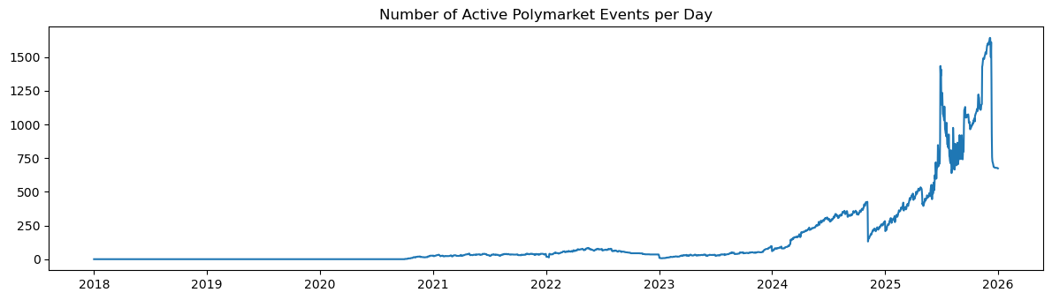
Appendix Figure A1. Active Polymarket event count rose sharply into late 2024 and 2025, highlighting the increasingly relevant macro-event layer.
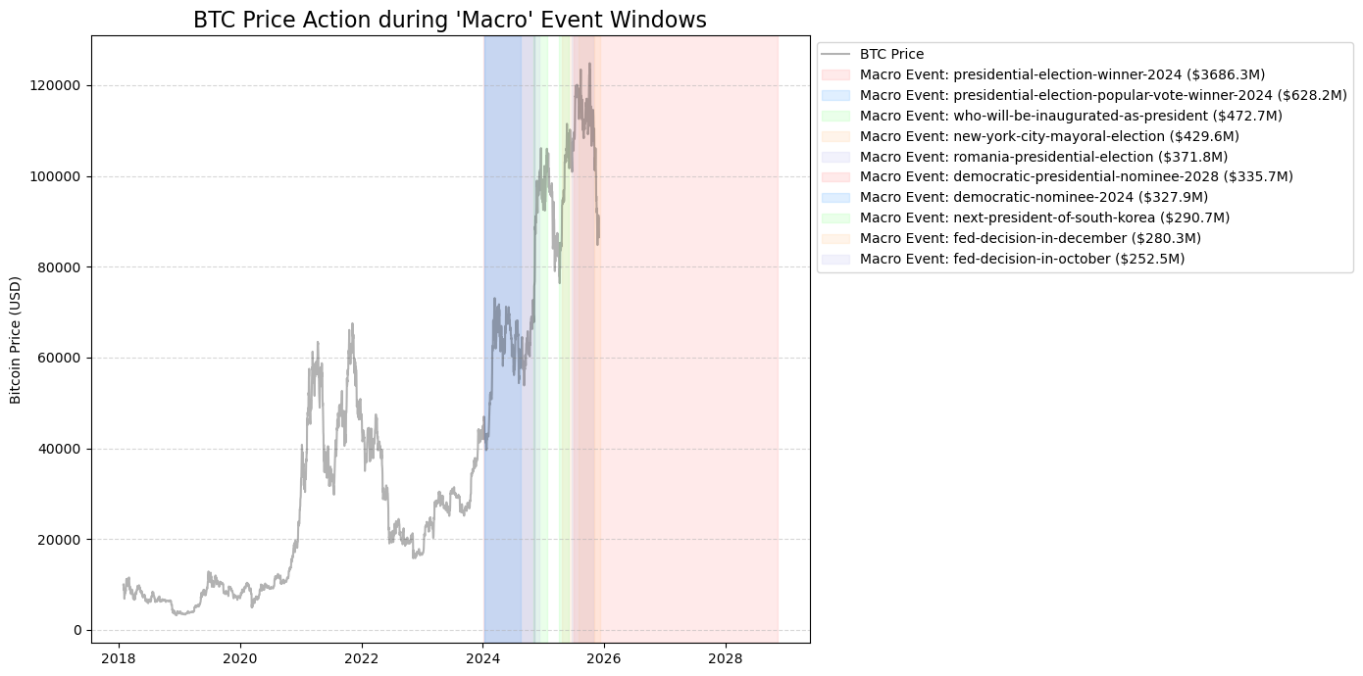
Appendix Figure A2. Major macro-event windows line up with important Bitcoin price phases and motivate the use of event-aware dampeners.
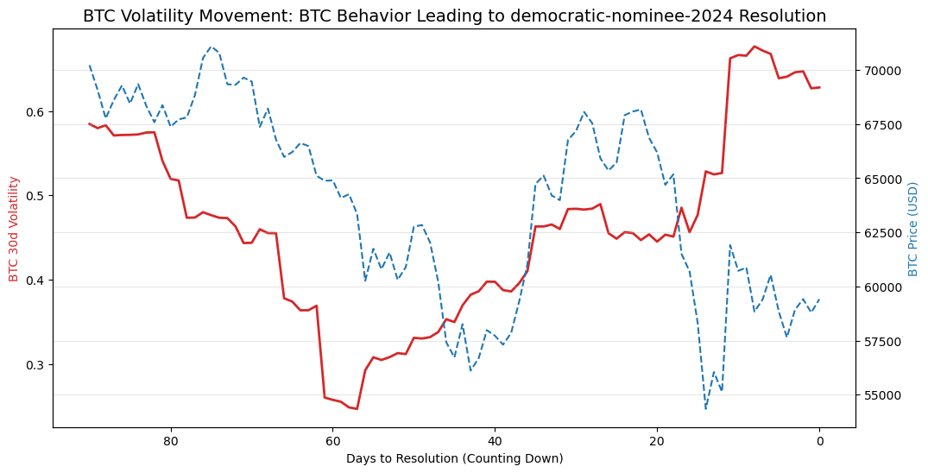
Appendix Figure A3. Example event-window analysis around democratic-nominee-2024 suggests volatility compression and repricing behavior as resolution approaches.
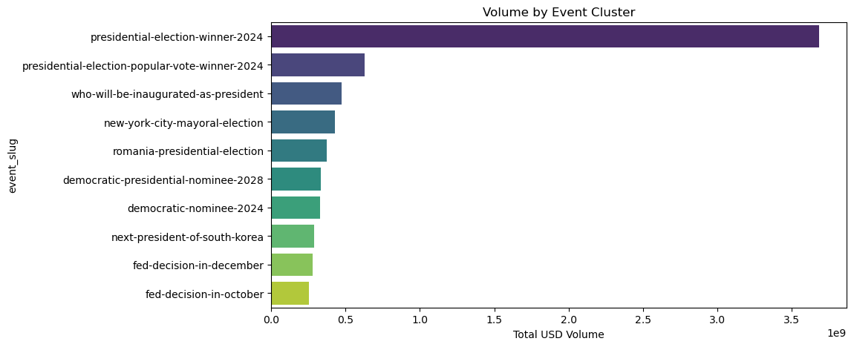
Appendix Figure A4. A small number of event clusters dominate total prediction-market volume, especially macro-political topics.
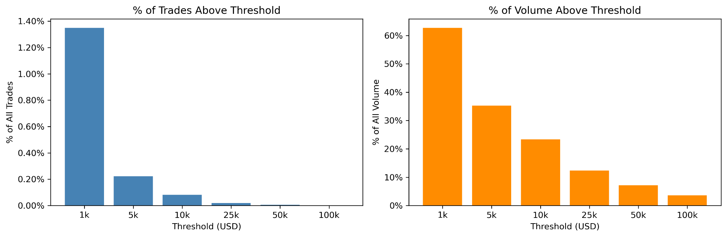
Appendix Figure A5. Whale threshold sensitivity checks support using a relatively high notional cutoff to isolate informative large trades.
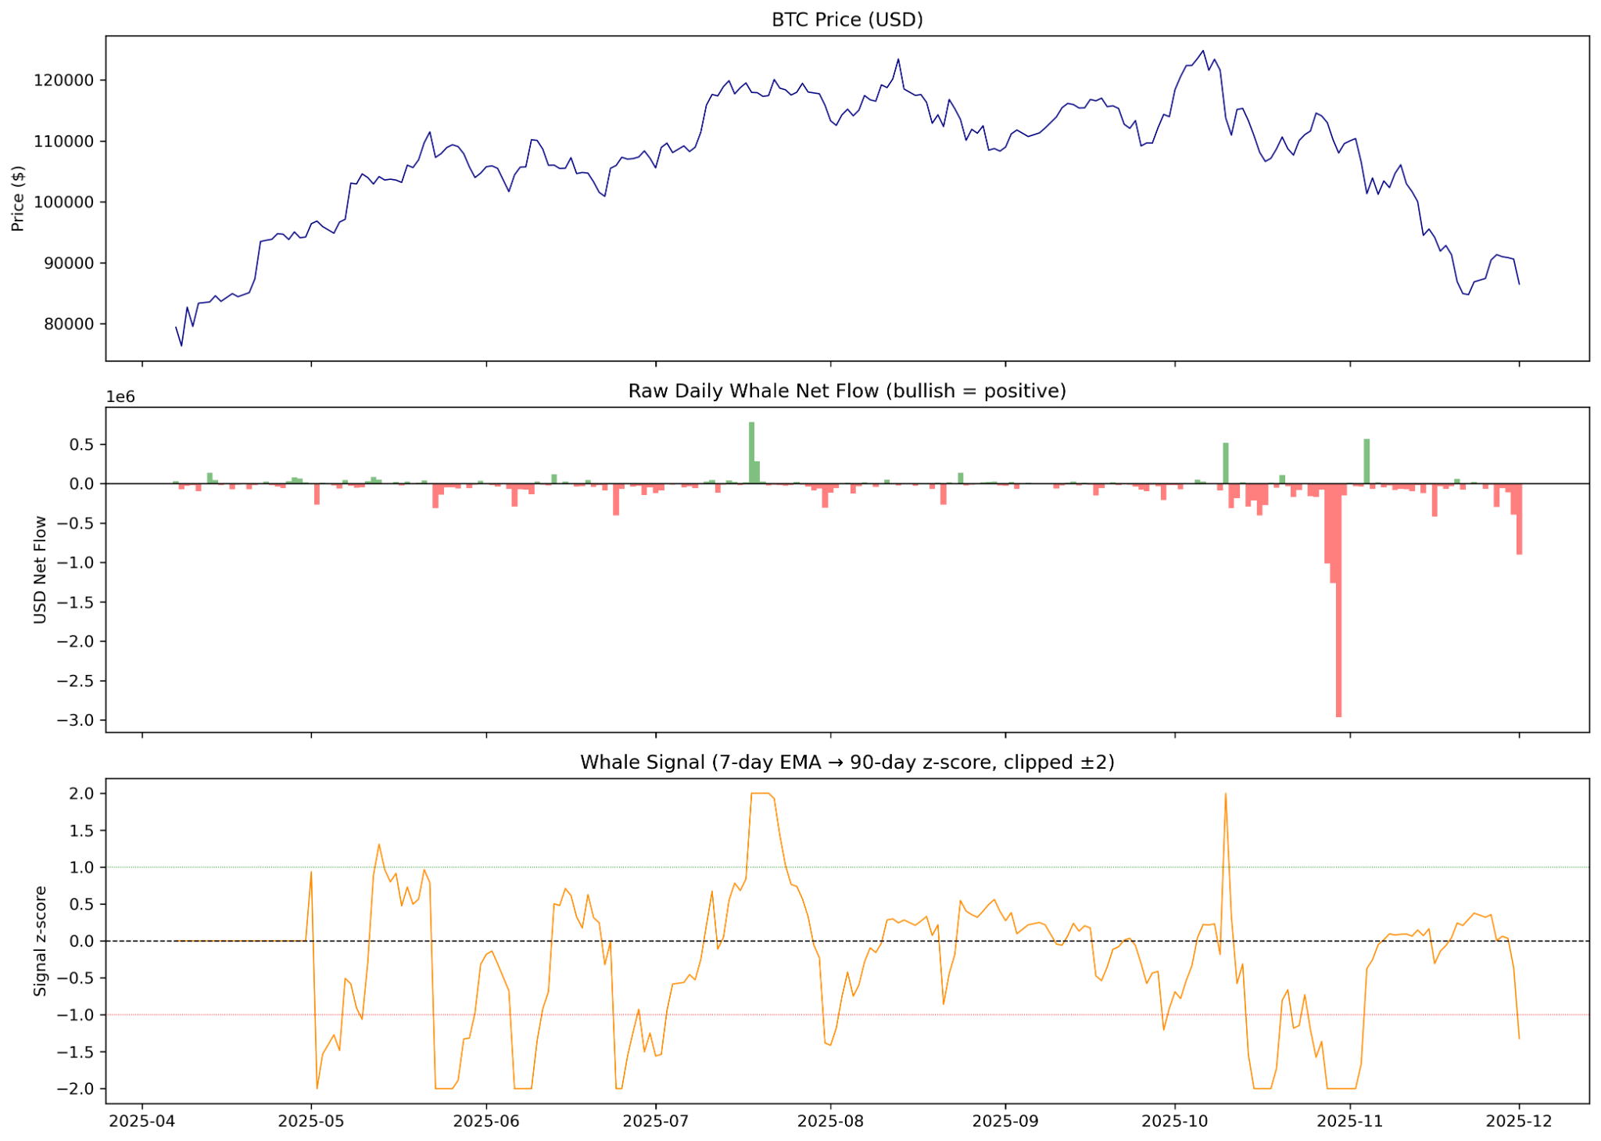
Appendix Figure A6. Raw whale net flow and smoothed whale signal illustrate how large-trade positioning varies through recent months.

